**Prepared By – Malini Roy Choudhury**

**Date: 10-08-2025**

**From Learning to Earning: Youth Education-to-Employment Transition in India**

**Abstract**

This study investigates how effectively youth aged 15–24 transition from education to employment across different education levels and regions in India. Using Census of India 2011 datasets. B-03 (ST): Workers by educational level and sex, and Special Tabulation on Adolescent and Youth Population. The research evaluates literacy, employment, and unemployment patterns to assess the strength of India’s education-to-employment pipeline.

Data was cleaned and analysed using Python (pandas, NumPy), transformed via Power Query, and visualized through Power BI dashboards. The national youth literacy rate stands at 86.14% (male: 90.04%, female: 81.85%), yet employment rates are significantly lower at 36.94% overall (male: 47.46%, female: 25.35%). Even among youth with technical or postgraduate qualifications, employment rates rarely exceed 50%, indicating limited labour market absorption.

Regional disparities are stark. Daman & Diu reports the highest youth employment (61.81%), while Lakshadweep and Puducherry fall below 16%. High-literacy states like Kerala and Lakshadweep struggle with job creation, suggesting a disconnect between education systems and local economies. Educated unemployment is concentrated in regions such as Lakshadweep (24.43%) and West Bengal (13.36%), with nearly 7% of youth actively seeking work but remaining unemployed.

Gender gaps persist in both literacy and employment, with women underrepresented despite comparable educational attainment. These findings reveal structural inefficiencies, skill mismatches, and regional labour market constraints.

The analysis offers insights for youth skilling and higher education planning. The study concludes with recommendations for targeted skilling programs, gender-inclusive employment policies, and state-specific strategies to better align education outcomes with labour market realities.

**1. Introduction**

**1.1 Motivation and Background**

Youth employment is a critical driver of inclusive economic growth, particularly in a nation like India, where nearly 27% of the population is aged 15–24. While education is widely regarded as the foundation for securing employment, evidence increasingly points to a misalignment between academic achievement and labour market integration. This disconnect not only limits individual career prospects but also impacts national productivity and economic stability. The title *From Learning to Earning* reflects the urgent need to understand how well education systems prepare youth for actual employment.

**1.2 Existing Survey and Literature Context**

Global reports by the International Labour Organization (ILO) and national surveys such as those by the National Sample Survey Office (NSSO) have consistently documented challenges in youth employment: gender gaps, underemployment, and the dominance of informal sector jobs. However, most studies either emphasize overall unemployment without differentiating by educational attainment, or they overlook state-wise disparities that can guide localized interventions.

**1.3 Research Gap**

Limited research connects educational level, gender, and geographic variation to actual employment outcomes for youth in India. This gap restricts evidence-based policymaking aimed at bridging the education employment divide.

**1.4 Research Objective**

The objectives of this study are to:

1. Assess literacy and employment rates for youth across education levels.
2. Identify regional variations in education-to-employment transitions.
3. Analysed gender disparities in both literacy and employment.
4. Propose policy interventions to strengthen the link between education and sustainable employment.

**1.5 Scope**

The study covers all Indian states and union territories, focusing on youth aged 15–24, using Census 2011 data. The analysis is designed to inform higher education policy, skilling initiatives, and state-specific labour market strategies.

**2. Materials and Methods**

**2.1 Data Sources**

* **Dataset 1:** *B-03 (ST): Workers classified by educational level and sex* (Census 2011).
* **Dataset 2:** *Special Tabulation on Adolescent and Youth Population* (Census 2011).

**2.2 Tools Used**

* **Python (Pandas, NumPy):** Data cleaning, merging, and computation of rates.
* **Power Query:** Preprocessing, filtering, and reshaping data tables.
* **Power BI:** Creation of interactive dashboards for visualization and analysis.

**2.3 Analytical Procedure**

1. **Data Acquisition & Cleaning:** Import raw Census datasets, standardize state names, remove inconsistencies, and handle missing values.
2. **Data Integration:** Merge employment and youth population datasets by state and education level.
3. **Indicator Computation:** Calculate literacy rates, employment rates, gender gaps, and educated unemployment percentages.
4. **Visualization:** Develop state-level and education-level dashboards to identify patterns.
5. **Reliability Checks:** Cross-verify computed rates with published Census figures to ensure accuracy.

**3. Results and Discussion**

* 1. **Youth Employment Rate by State**

**Key Insight:** Daman & Diu and Dadra & Nagar Haveli show highest employment; Lakshadweep and Puducherry the lowest.

**Results:**

* National Employment Rate: 36.94%
* Male: 47.46%
* Female: 25.35%
* Highest Employment: Daman & Diu (61.81%), Dadra & Nagar Haveli (56.32%)
* Lowest Employment: Lakshadweep and Puducherry (~15.62%)

**Discussion:**The stacked column chart reveals sharp contrasts in youth employment across regions. Daman & Diu (61.81%) and Dadra & Nagar Haveli (56.32%) both union territories outperform the national average of 36.94%, while Lakshadweep and Puducherry hover around 15.62%. Among states, Chhattisgarh and Rajasthan show relatively strong performance. This raises questions about governance models, industrial presence, and migration dynamics. Low employment in Lakshadweep may stem from limited economic diversity and conservative gender norms restricting female participation, despite high literacy.

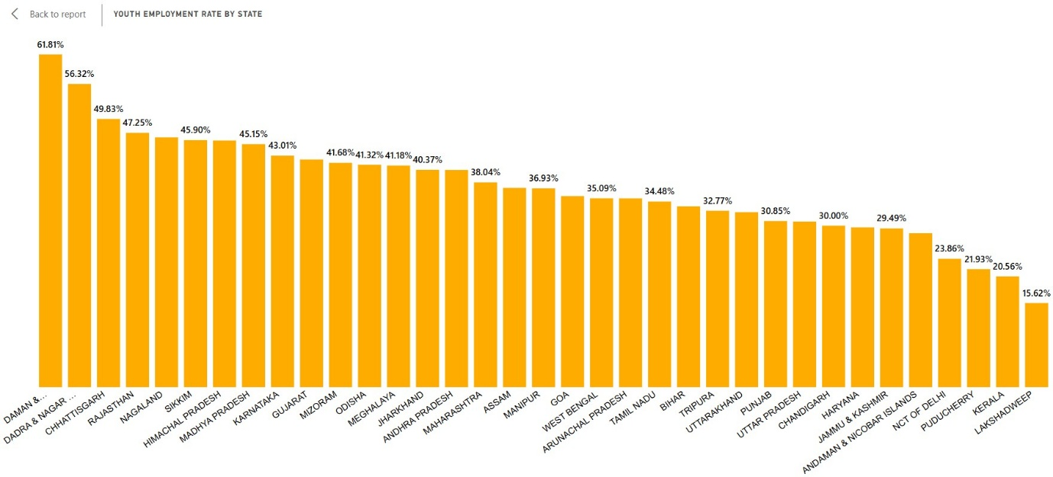

**3.2 Youth Literacy Rate by State**

**Key Insight:** Kerala, Lakshadweep, and Puducherry lead in youth literacy, exceeding 96%.

**Results:**

* National literacy: 86.14%
* Male: 90.04% Female: 81.85%
* Top states: Kerala (99.04%), Lakshadweep (97.49%), Puducherry (96.41%)
* Low states: Bihar (72.29%)

**Discussion:**Kerala (99.04%), Lakshadweep (97.49%), and Puducherry (96.41%) lead in youth literacy, far above the national average of 86.14%. Yet employment remains low, especially for women. The stacked column chart shows gender gaps of ~8.2%. This prompts questions: Does literacy translate into employability? Are cultural expectations limiting workforce entry? High literacy doesn’t dismantle social barriers. States must align education with local job markets and address gendered norms to convert learning into earning.

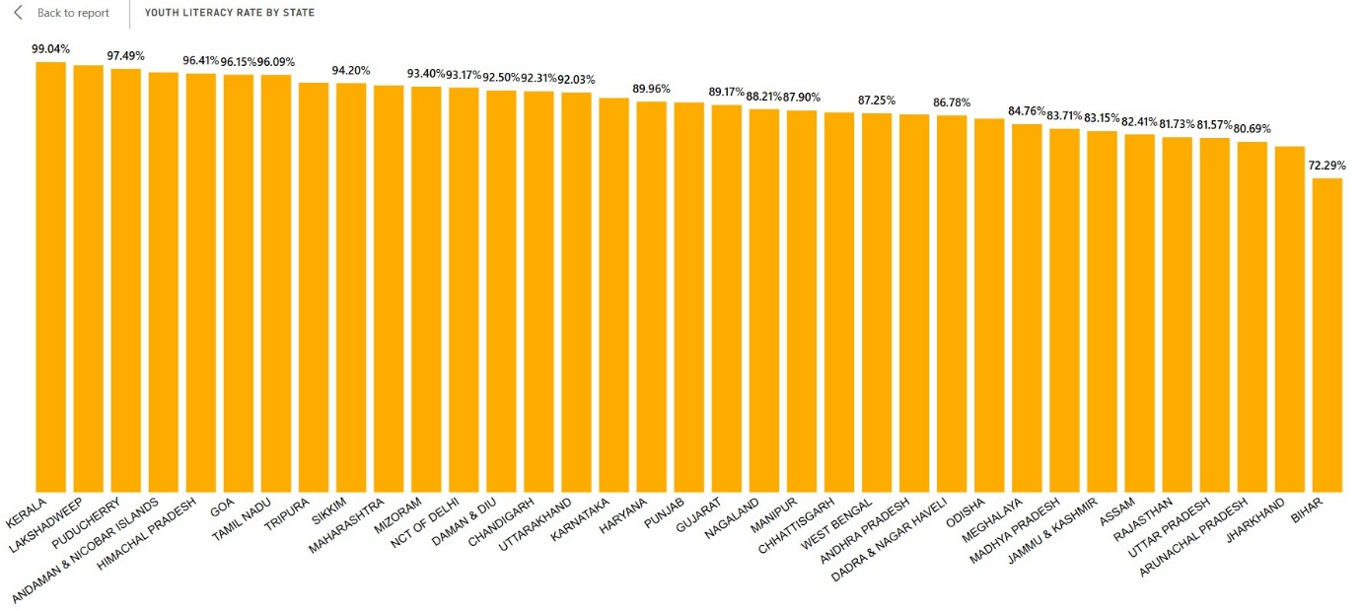

**3.3 Youth Employment Status**

**Key Insight:** Only 36.94% of youth are employed; the majority remain out of the labour force.

**Results:**

* Employment rate: 36.94% while in rural: 41.49% and urban: 27.05%
* Main workers: 71.49% while in rural: 66.69% and urban: 85.13%
* Marginal workers: 28.51% while in rural: 33.31% and urban: 14.87%

**Discussion:**Only 36.94% of youth are employed nationally, with rural areas (41.49%) ahead of urban (27.05%). The pie chart shows that 71.49% are main workers, while 28.51% are marginal often in unstable jobs. Urban youth are more likely to be in formal roles, while rural youth face informal sector dominance. Why are educated youth disengaged? Gender-based exclusion and lack of opportunity persist. Inclusive hiring, targeted skilling, and better rural-urban job distribution are essential to activate youth potential.

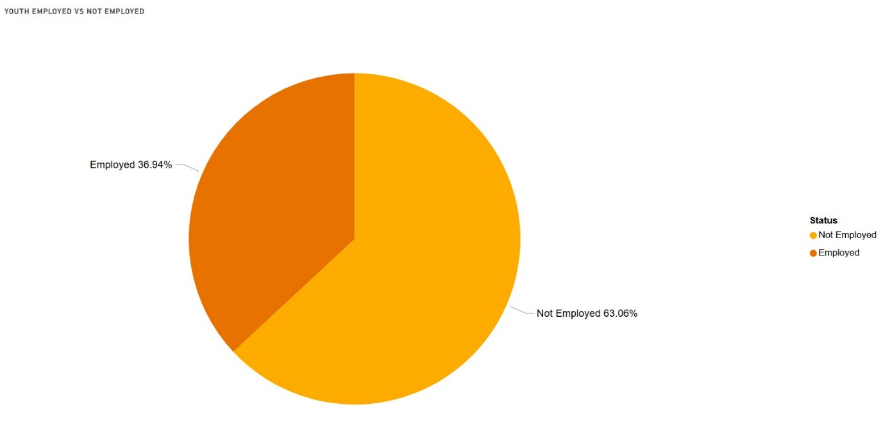

**3.4 Employment % by Education Level**

**Key Insight:** Graduate and above (67.20%) and technical degrees (64.11%) yield the highest employment rates, but still below 50%.

**Results:**

* Overall employment by education: 48.30%
* Male: 54.19% Female: 41.97%
* Best outcomes: Technical diplomas, postgraduate degrees

**Discussion:**Graduates and technically qualified youth show higher employment rates postgraduates at 67.20%, technical diploma holders at 64.11% yet overall employment remains below 50%. The stacked column chart reveals that even the most educated youth struggle to find stable jobs. Is there a mismatch between academic training and market needs? The data suggests industry-academia disconnects, lack of soft skills, and regional stagnation. Strengthening vocational pathways and employer partnerships could make education more outcome-oriented and responsive to demand.

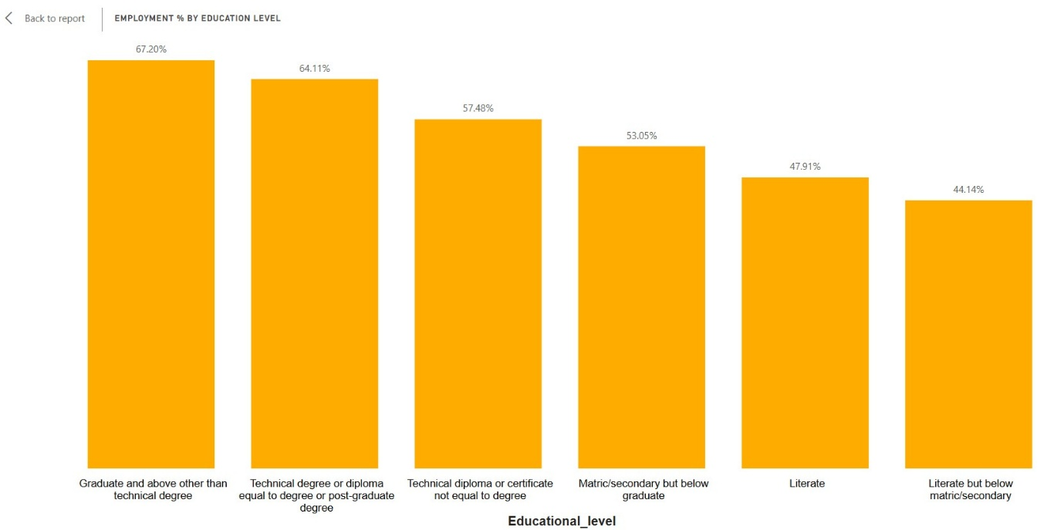

**3.5 Education-to-Employment Gap by State**

**Key Insight**: Lakshadweep and West Bengal show high educated unemployment despite strong literacy.

**Results:**

* National educated unemployment: 5.20%
* Male: 4.44% Female: 6.25%
* High-risk regions: Lakshadweep (24.43%), West Bengal (13.36%)
* Low-risk regions: Gujrat (2.74%), Chhattisgarh (2.96%)

**Discussion:**Lakshadweep (24.43%) and West Bengal (13.36%) show high educated unemployment despite strong literacy. The stacked column chart highlights regions where qualifications don’t translate into jobs. National educated unemployment stands at 5.20%, with female rates higher (6.25%). Why are skilled youth jobless? Weak industrial bases, cultural constraints, and limited private sector growth may explain the gap. These regions need localized skilling programs, entrepreneurship support, and better job matching to convert education into employment.

.

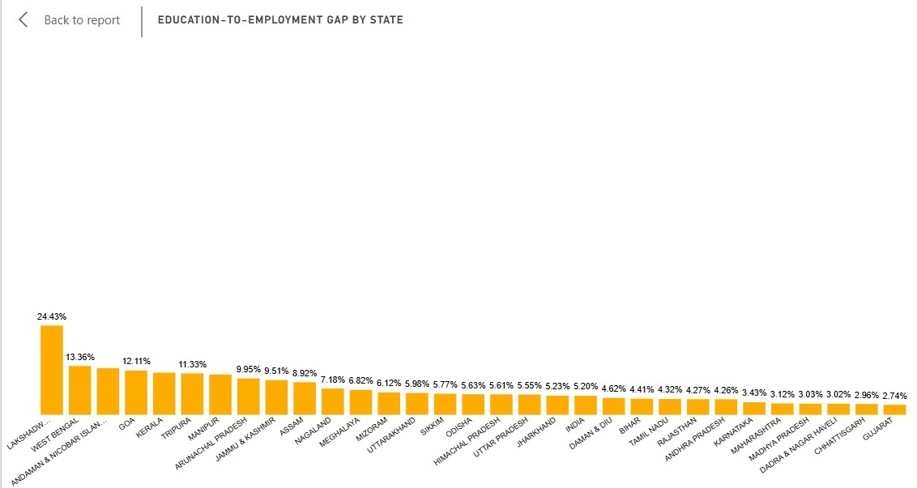

**3.6 Non-Workers Seeking Work by State**

**Key Insight:** Lakshadweep, West Bengal, and Kerala have the highest share of youth actively seeking work.

**Results:**

* National rate: ~7% (Male: 7.09% and Female :7.51%)
* Top states: Lakshadweep (36%), West Bengal (25%), Kerala (23%)

**Discussion:**Matrix charts show Lakshadweep (36%), West Bengal (25%), and Kerala (23%) have the highest share of youth actively seeking work. Nationally, ~7% of youth are job seekers (male: 7.09%, female: 7.51%). Why are educated youth unable to find jobs? Poor job matching, limited opportunities, and regional policy gaps contribute. High job-seeking rates in literate states reveal frustration and misalignment. Demand-driven skilling, career guidance, and region-specific employment strategies are needed to bridge this divide.

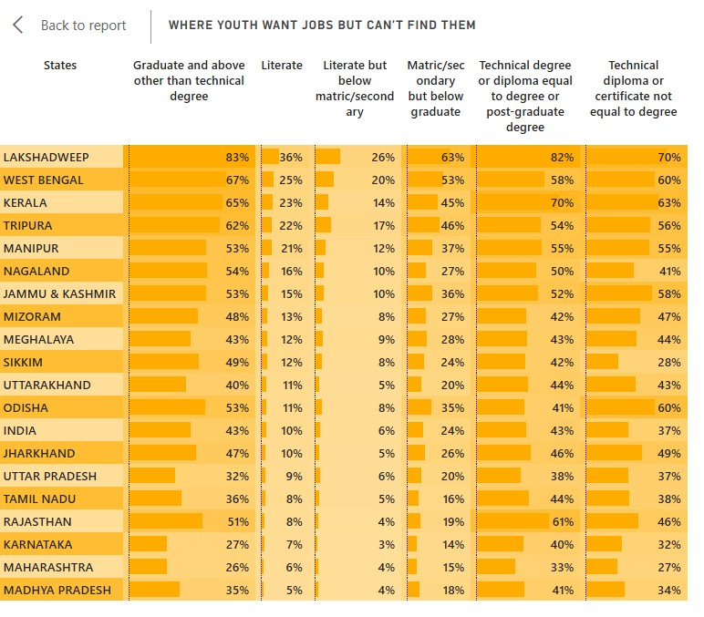

**4. Conclusion**

**Objectives Revisited**

This study evaluated youth literacy and employment trends across India, with a focus on gender and regional disparities. It aimed to identify gaps in the education-to-employment pipeline and propose actionable policy recommendations.

**Key Findings**

* High literacy rates do not guarantee employment, especially in union territories and high-literacy states.
* Gender gaps remain significant in both education access and labour force participation.
* Regional disparities highlight the role of localized economic structures and limited job diversity.
* Educated unemployment is rising, even among youth with technical and postgraduate qualifications

**Implications**

* Skilling programs must be tailored to local industry needs and economic contexts.
* Gender-inclusive employment policies are essential to improve participation and equity.
* State-specific strategies are needed to bridge the education-employment divide, including better career guidance, entrepreneurship support, and labour market alignment.

**Recommendations for Future Research**

* Use post-2011 datasets to track progress.
* Explore vocational training and emerging industries.
* Assess the impact of digital skilling and entrepreneurship programs.

**5. References**

1. Census of India 2011, B-03 (ST): Workers classified by educational level and sex.
2. Census of India 2011, Special Tabulation on Adolescent and Youth Population.
3. International Labour Organization (ILO), *Global Employment Trends for Youth*, latest edition.
4. National Sample Survey Office (NSSO), *Employment and Unemployment Situation in India*, relevant rounds.